1. On contact, remove the address and leave only the email
2. Put/hide the tel number somewhere at the bottom. That number is not working for now. Maybe we should just remove it for now
3. [FB.](https://ade00762.github.io/jecsltd2/index.html) [LN.](https://ade00762.github.io/jecsltd2/index.html) [TW.](https://ade00762.github.io/jecsltd2/index.html) [IN.](https://ade00762.github.io/jecsltd2/index.html) what is this at the top beside where the email is?
4. [Terms & Condition](https://ade00762.github.io/jecsltd2/index.html) [Privacy Policy](https://ade00762.github.io/jecsltd2/index.html) I think this should be removed
5. Is the contact us form sending mails to [info@jecslimited.com](mailto:info@jecslimited.com)?
6. Can we change the oyinbo pictures to blacks lol?
7. Remove this on About us page

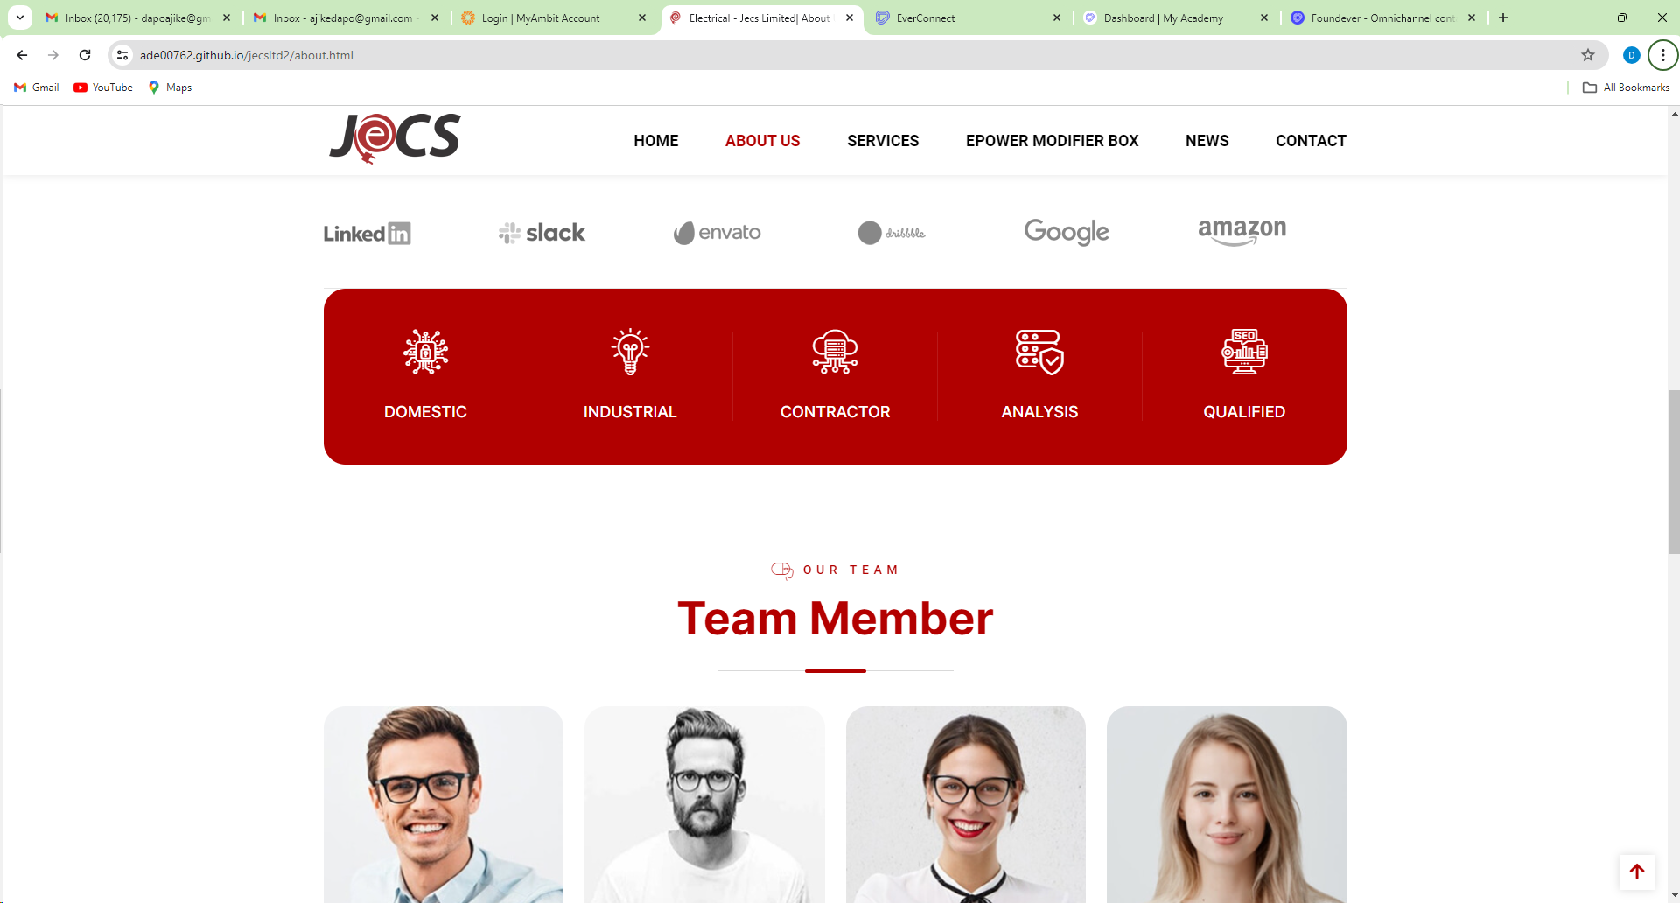

1. You did not add the details on the services e.g.

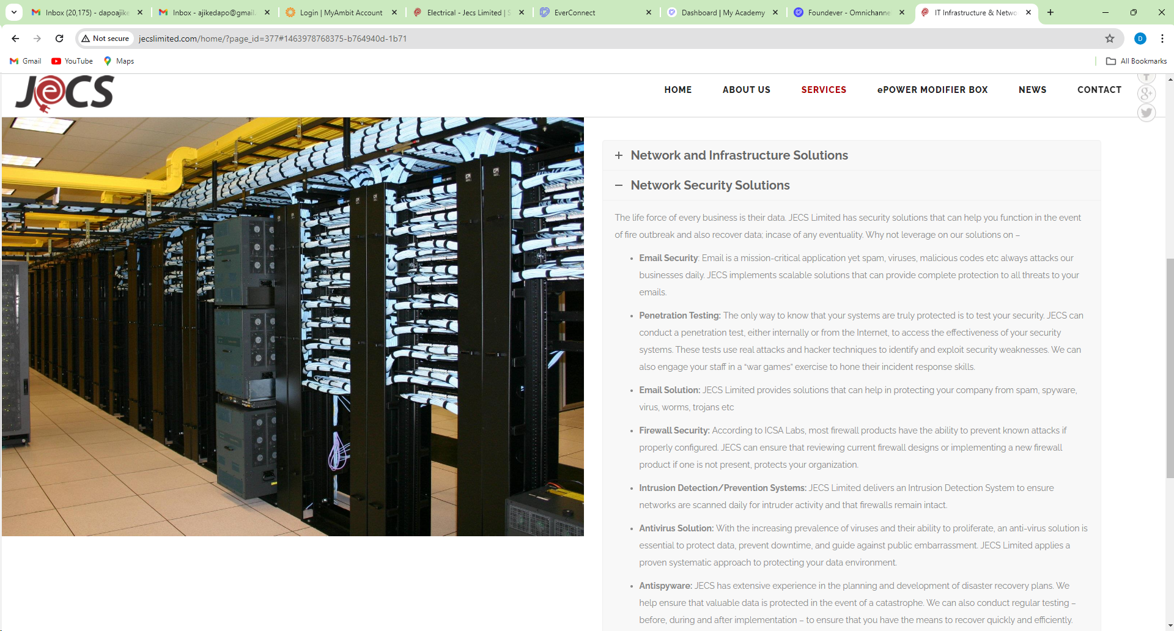

1. Can we get pictures like this that shows tech

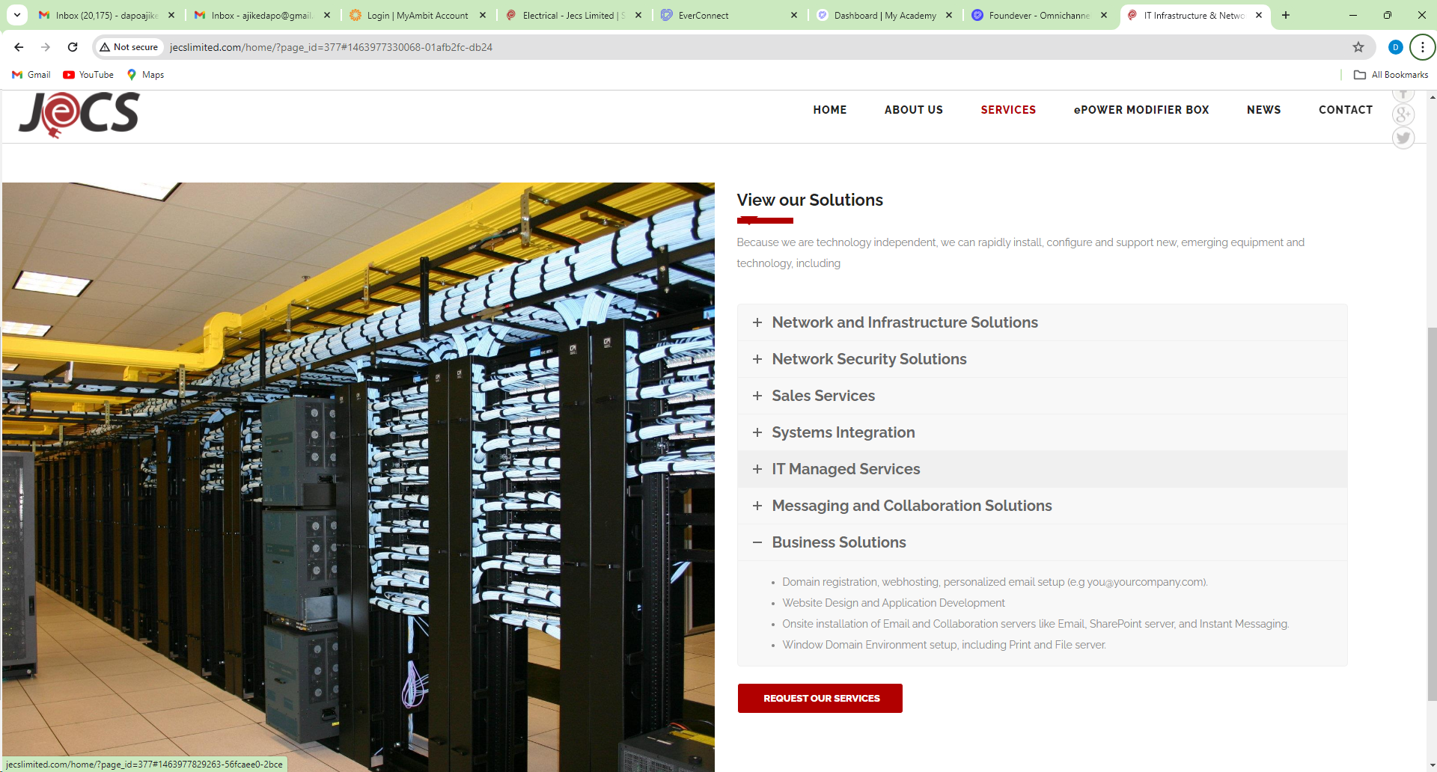

1. Can we make this better bulleted

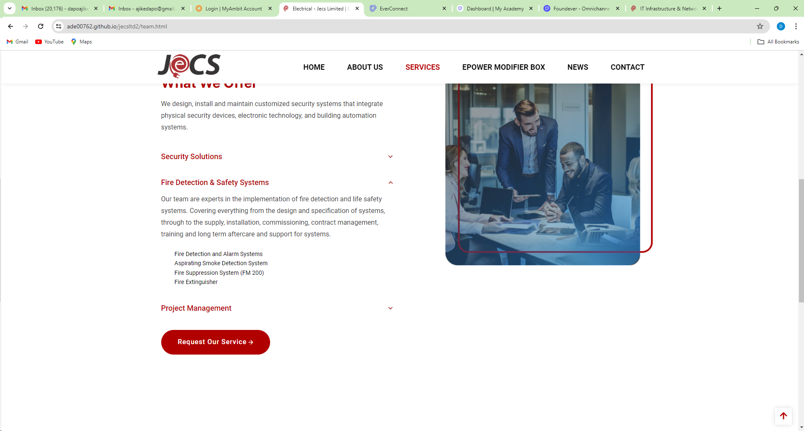

1. Can you do this just like this? I terms of font format?

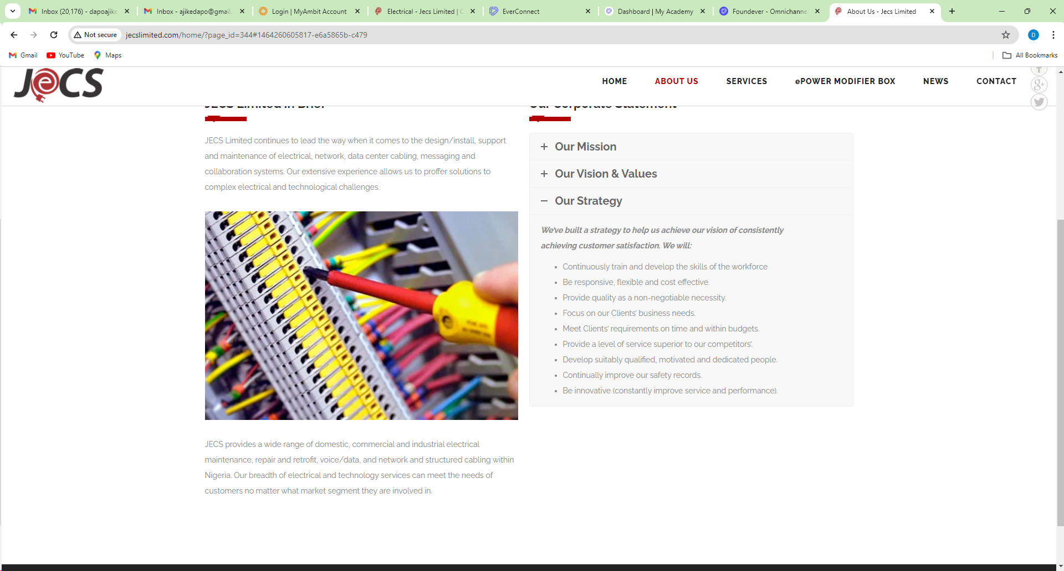

1. I discovered you added services that were not on the original site. Just use everything we have on the original site with font size, style, italics, bold etc